 SRI VENKATESWARA COLLEGE OF ENGINEERING &TECHNOLOGY

[AUTONOMOUS]

R.V.S NAGAR, CHITTOOR-517127.

**DEPARTMENT OF MECHANICAL ENGINEERING**

**(Accredited by NBA)**

CIRCULAR

Date: 17.10.2022

The IVyear B.Tech ME students are informed to register for “Career Opportunities” program by

Dr. Muraleedharan, SVCE-Chennai. The details of the program are listed below.

**Program Details**

|  |  |
| --- | --- |
| **Program Name** | “Career opportunities” |
| **Date and Time** | Date : 19thoctober 2022,  Wednesday.  Time : @ 10 : 00 a.m. |
| **Resource Person** | Dr. Muraleedharan  Prof. CSE & Head of Placements  SVCE-Chennai |
| **Venue** | E-Class Room R-221 |



**HOD ME**

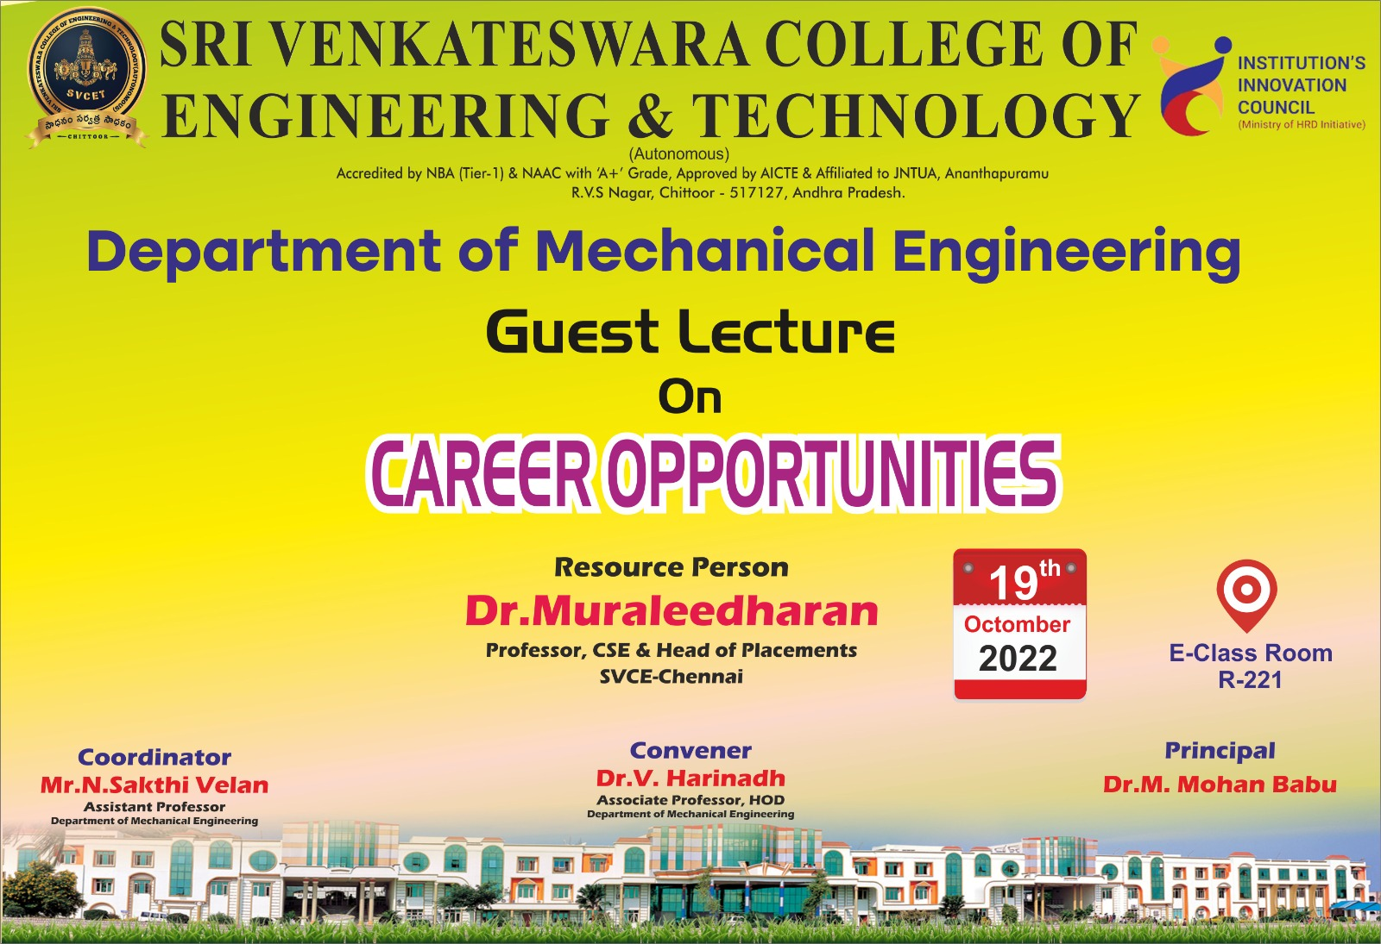

**SRI VENKATESWARA COLLEGE OF ENGINEERING & TECHNOLOGY**

**[AUTONOMOUS]**

**R.V.S Nagar, Chittoor, A.P. - 517127**

**DEPARTMENT OF MECHANICAL ENGINEERING**

**(Accredited by NBA)**

***Report of “Career opportunities”***

*19th October 2022*

**Objectives & Context: Date: 21.10.2022**

The proposed programme on “Career opportunities” is aimed at the participants to get awareness on career opportunities for engineering students. Engineering is one of the most preferred undergraduate degree courses among students from the Science stream post-school. The 4-year course is offered by many engineering colleges across India.

**Participants:**

The IVyear students of Mechanical Engineering have attended the program to get the awareness on opportunities for engineering students related to their career. A total of **47** participants are participated in the Awareness program on “Career Opportunities”.

**Resource person:**

Dr. Muraleedharan

Prof. CSE & Head of Placements

SVCE-Chennai

**Outcome:**

The participants have got awareof opportunities for engineering students for their better future. Participated students are able to recognize the broad range of career options, including different kinds of engineering roles, jobs in related areas such as supply chain and jobs in other industries such as finance and IT.

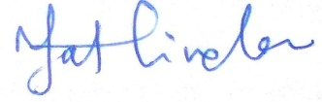

**COORDINATOR HOD M.E.,**

**SRI VENKATESWARA COLLEGE OF ENGINEERING & TECHNOLOGY**

**[AUTONOMOUS]**

**R.V.S Nagar, Chittoor, A.P. - 517127**

**DEPARTMENT OF MECHANICAL ENGINEERING**

**(Accredited by NBA)**

**List of students attended the program on “Career opportunities” organised on 19.10.2022**

|  |  |  |
| --- | --- | --- |
| **S.No.** | **Reg. No.** | **Student Name** |
| 1 | 19781A0302 | B RAJA KUMAR |
| 2 | 19781A0303 | BANGAR MAHAMMED GHOUSE |
| 3 | 19781A0304 | BONTHALA LEELADHAR |
| 4 | 19781A0305 | CHILAMAKURI VISHNU VARDHAN NAIDU |
| 5 | 19781A0306 | G SOMASEKHAR |
| 6 | 19781A0307 | G VENU |
| 7 | 19781A0308 | GADDAM ABDUL KALAM |
| 8 | 19781A0309 | J VITAL |
| 9 | 19781A0310 | K S JOHN |
| 10 | 19781A0311 | KONANKI VARUN KUMAR |
| 11 | 19781A0315 | M PRATHAP |
| 12 | 19781A0316 | NUTHANAPATI TEJA |
| 13 | 19781A0317 | PATHAN ASAD ALI KHAN |
| 14 | 19781A0318 | PATOORU AJAY |
| 15 | 19781A0319 | R CHARAN |
| 16 | 19781A0320 | S SHAHBAZ SHERIFF |
| 17 | 19781A0321 | SHAIK GHOUSE BASHA |
| 18 | 19781A0326 | NITEESH KUMAR SHARMA |
| 19 | 19781A0327 | RISHI KESH KUMAR |
| 20 | 19781A0328 | SHANI RAJAN |
| 21 | 19781A0329 | DHIRAJ KUMAR |
| 22 | 19781A0330 | KULDEEP KUMAR |
| 23 | 19781A0331 | RAHUL KUMAR |
| 24 | 19781A0334 | GIRAJ KUMAR |
| 25 | 19781A0335 | DANISH SAFIR |
| 26 | 19781A0336 | DEEPAK KUMAR MAHTO |
| 27 | 19781A0342 | NIRAJ KUMAR PANDEY |
| 28 | 20785A0301 | ALIVELU PRASHANTH |
| 29 | 20785A0302 | ANAGIMTI PRAMODH |
| 30 | 20785A0303 | ANDLURU ANIL KUMAR REDDY |
| 31 | 20785A0304 | AVULAKUNTA VASUDEVA |
| 32 | 20785A0305 | B YATHESWAR |
| 33 | 20785A0306 | BATTULA VEERA PHANEENDRA REDDY |
| 34 | 20785A0307 | BESTHA SAI CHARAN |
| 35 | 20785A0308 | BHIMAVARAPU MAHESH KUMAR |
| 36 | 20785A0309 | BORRI SHASHANK |
| 37 | 20785A0310 | CHEEPATI SIVA SANKAR |
| 38 | 20785A0311 | CHEJARLA KIRANKUMAR |
| 39 | 20785A0312 | CHITTEPU HARSHAVARDHAN REDDY |
| 40 | 20785A0338 | RAMAVATH BALAJI NAIK |
| 41 | 20785A0339 | SATARLA SATHISH |
| 42 | 20785A0340 | SETTY MALLIKARJUNA |
| 43 | 20785A0341 | SHAIK ABDUL KHADAR |
| 44 | 20785A0342 | SHAIK ADIL AHAMAD |
| 45 | 20785A0347 | TIRUMALA MANI KUMAR |
| 46 | 20785A0348 | VALLEPU CHANDRA MOULI |
| 47 | 20785A0349 | VALMIKI RAVI PRAKASH |



**COORDINATOR HOD M.E**